**MAJOR PROJECT**

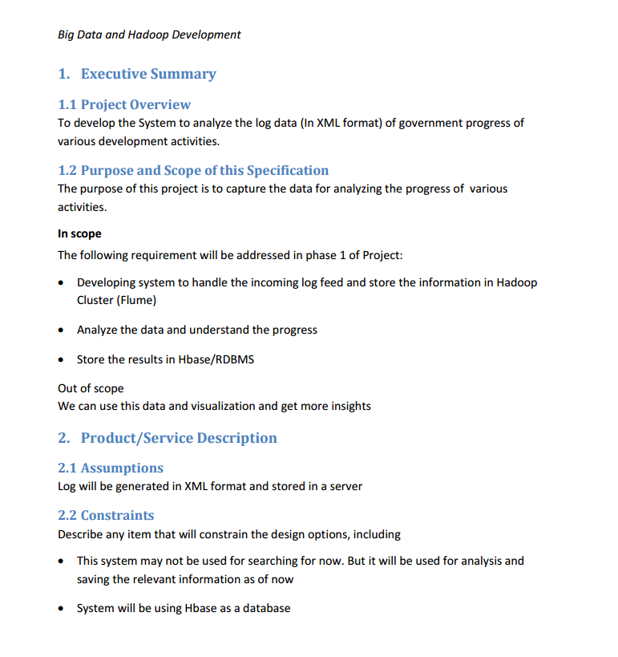

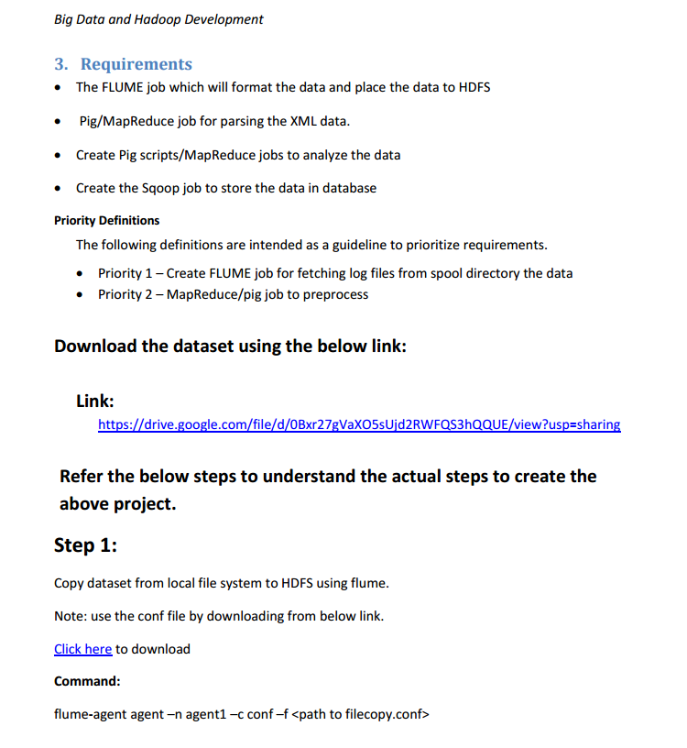

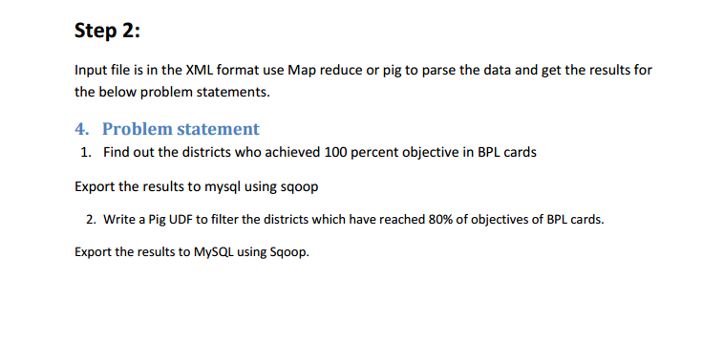

**STAGE-1:**

The dataset is in XML format. In the 1st stage of the project, the dataset is copied from local file system to HDFS using flume.

//flume configuration file

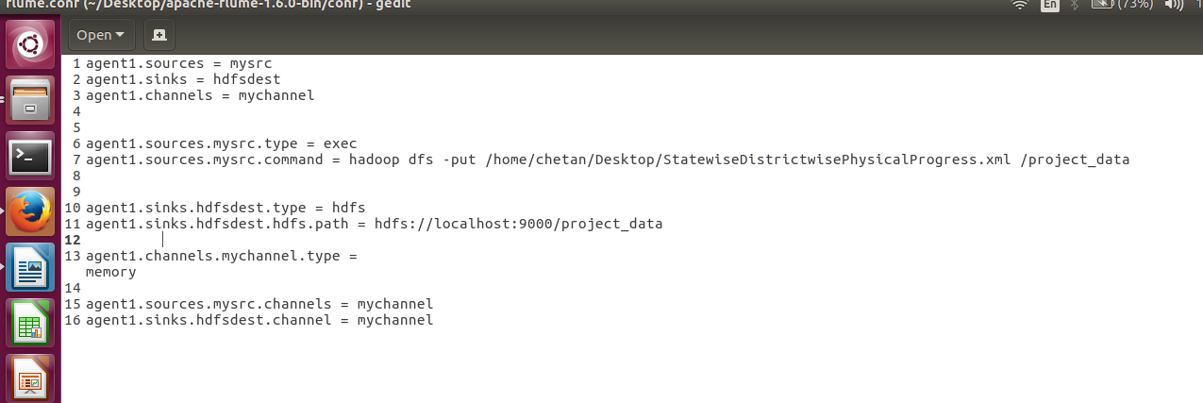

//creating output directory

//running flume agent

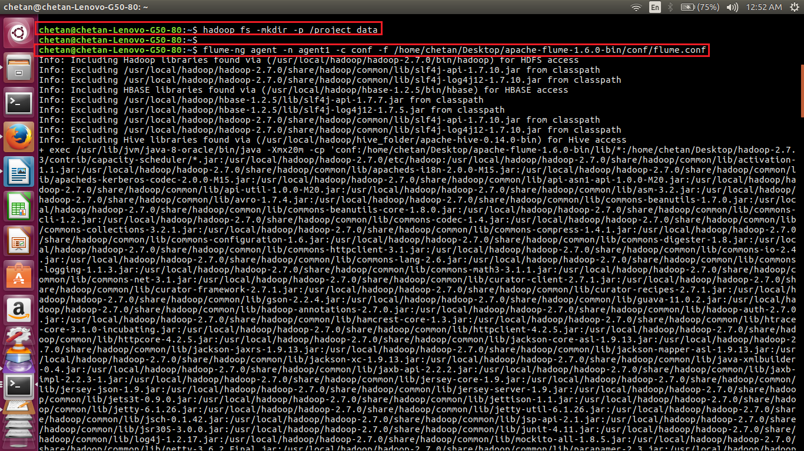

//flume is running

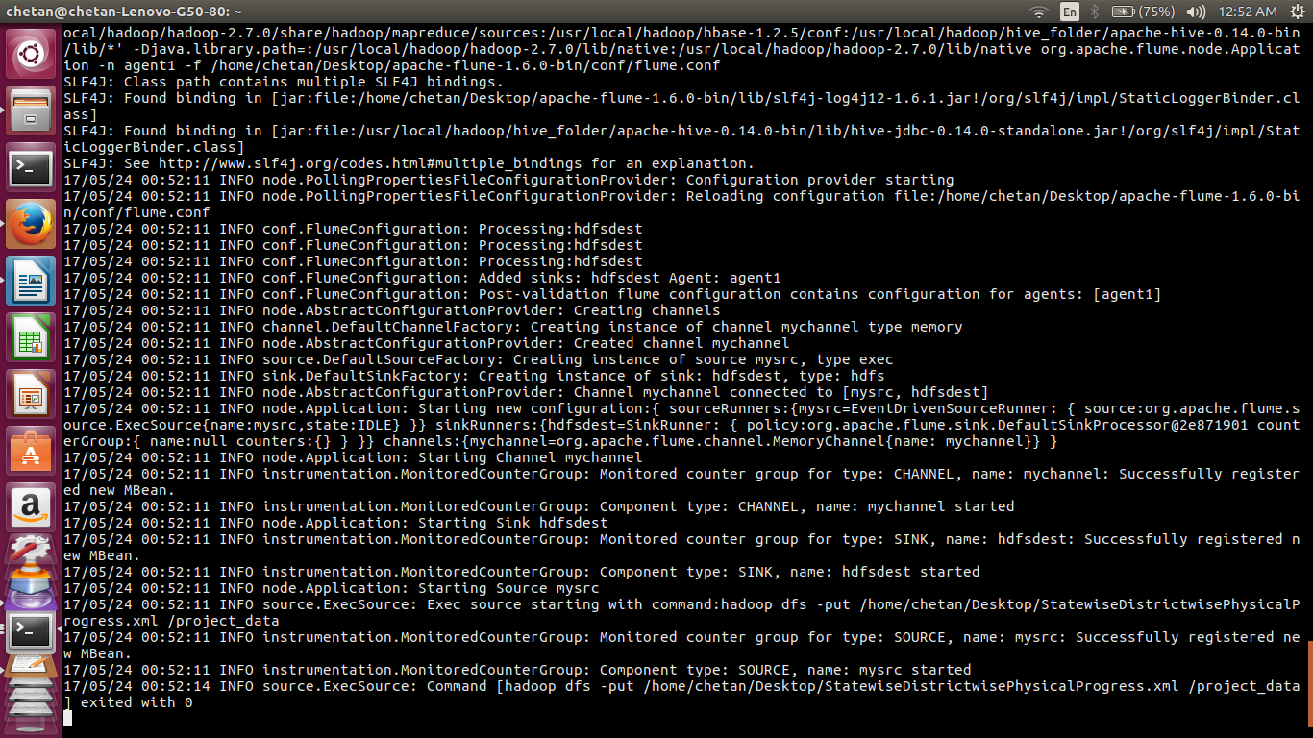

//flume exited with 0 i.e. file is successfully copied to /project_data directory

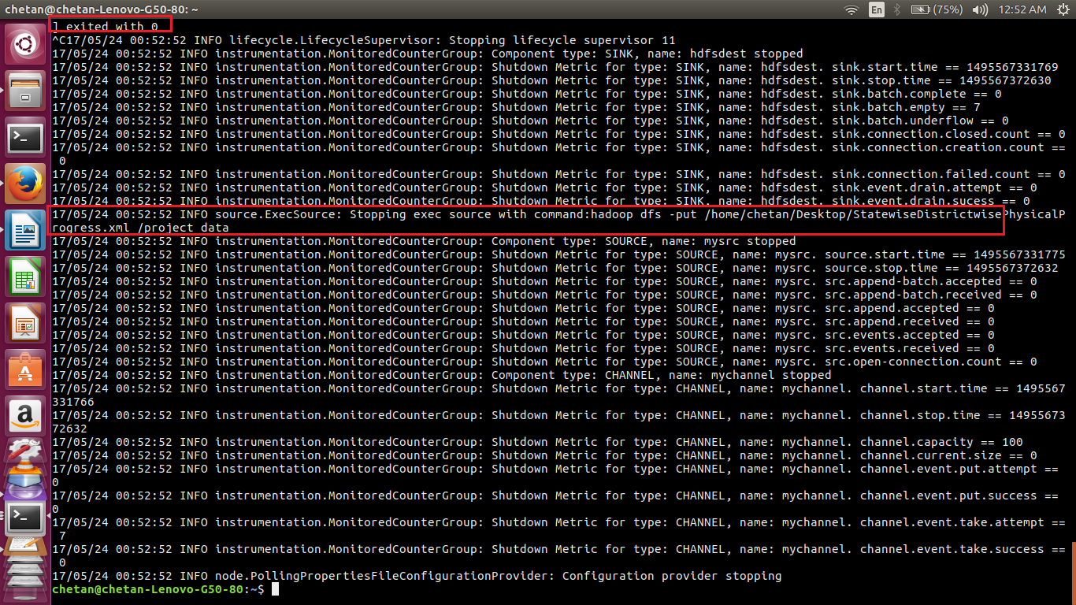

//displaying the contents of the directory project_data

As seen in the screenshot below, the xml file is copied to HDFS.

A sample record is the file is displayed using cat command.

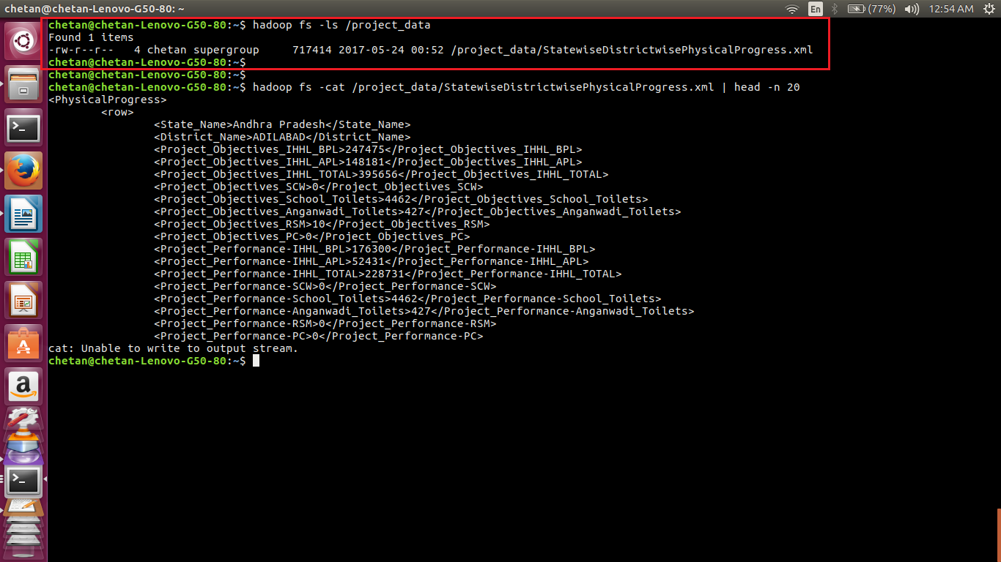

**STAGE-2:**

In 2nd stage, the xml file is converted to csv file using pig script.

//pig script to convert xml to csv

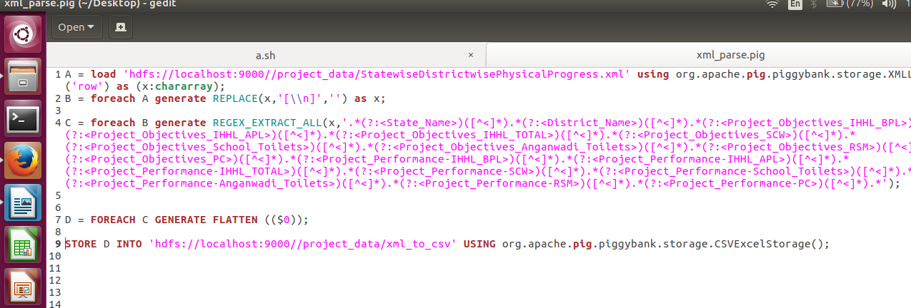

//running pig script

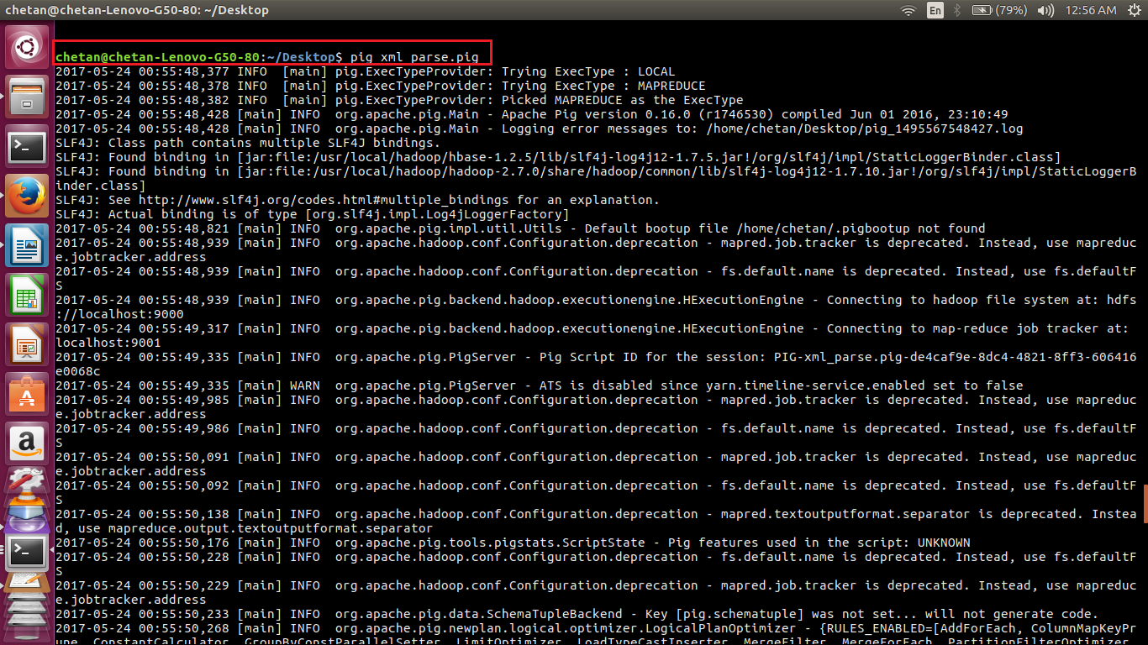

//pig script is running

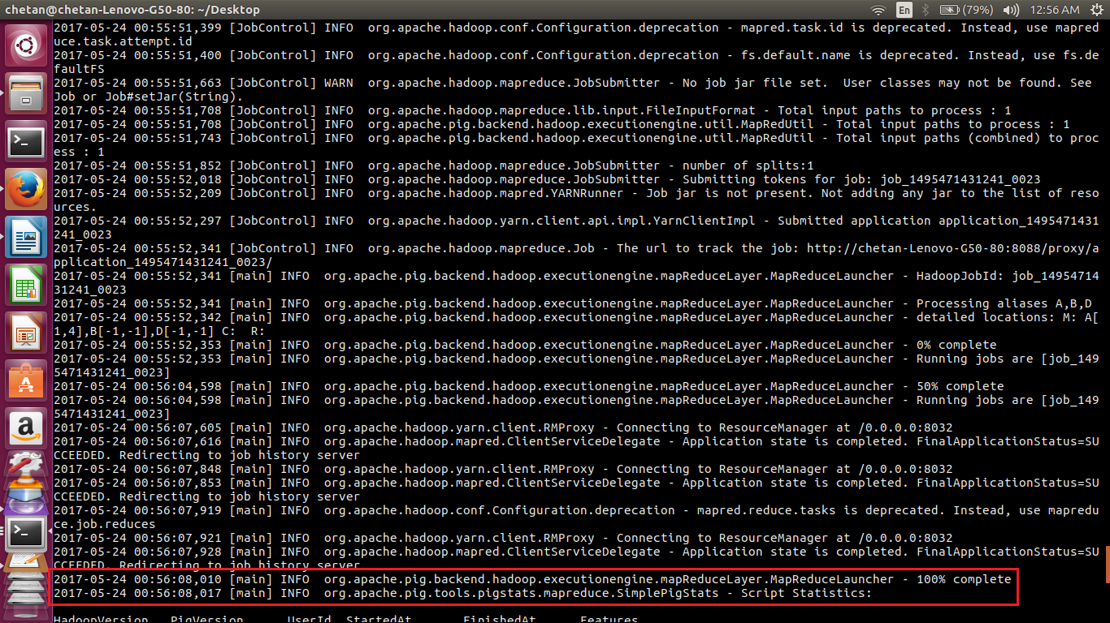

//pig script executed successfully

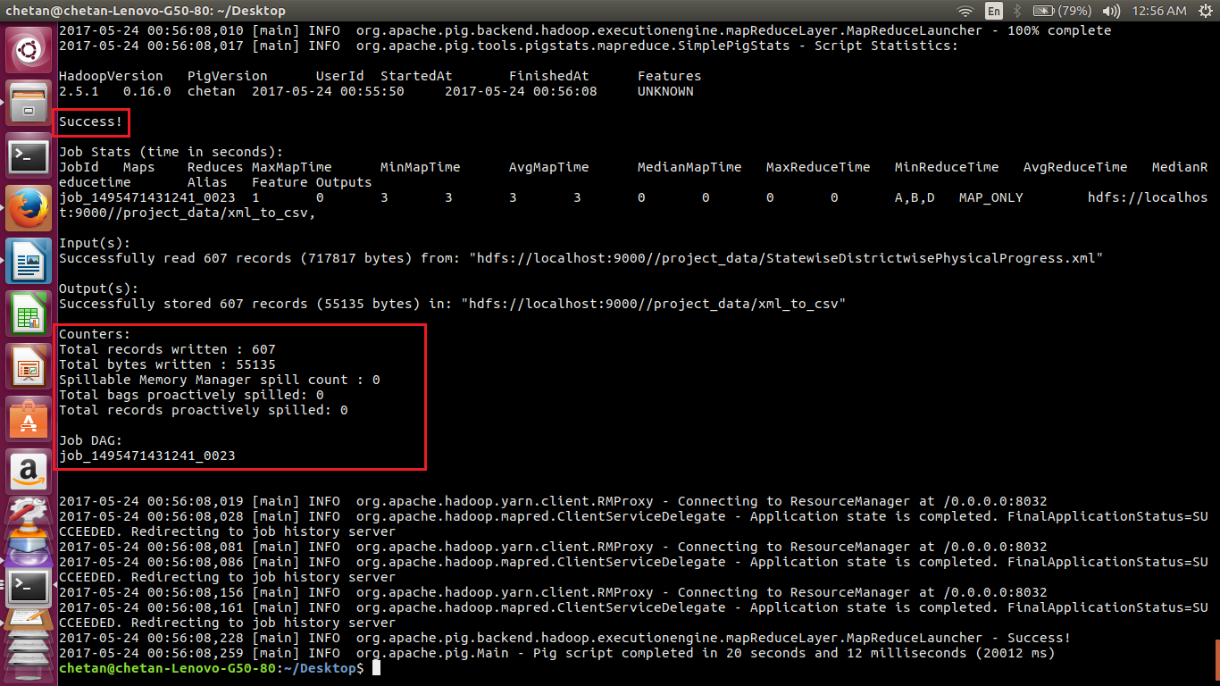

//displaying the contents of the output directory directory.

As seen in the screenshots below, the directory contains part-r-00000 file, which indicates that the pig script is executed successfully.

On displaying the contents of the part-m-00000 file using cat command, it can be seen that the file contains comma separated values.

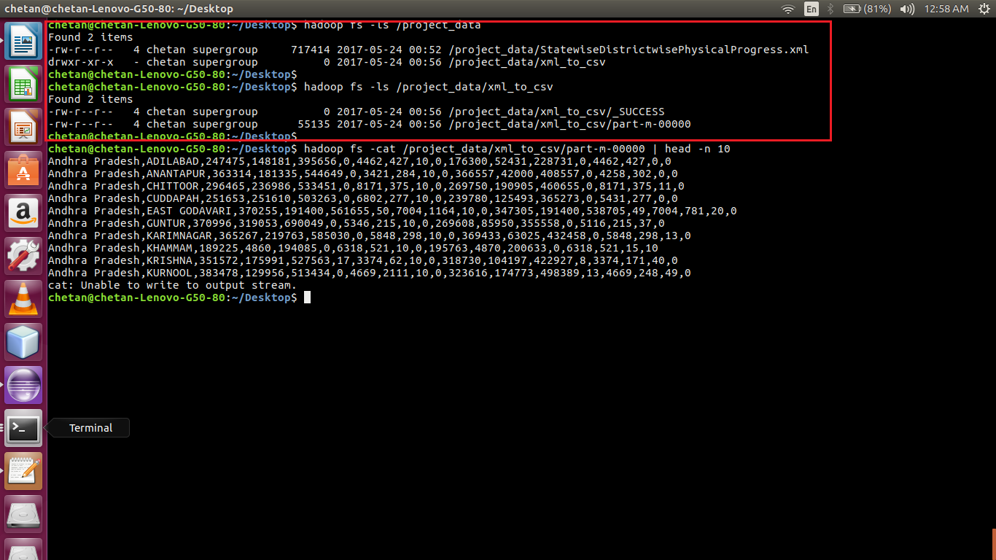

**STAGE-3:**

In 3rd stage, a pig script is written for the following:

Q1-Find out the districts who achieved 100 percent objective in BPL cards.

Later, the results are exported to mysql using sqoop.

//pig script

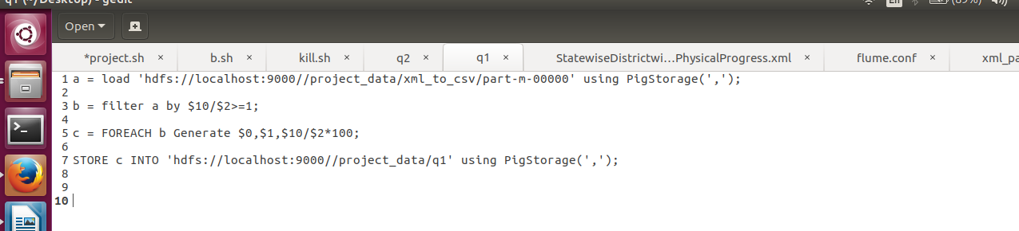

1. Load the dataset.

2. Calculate the percentage.

3. Filter the results where percentage is greater than equal to 100.

4. Generate the required the columns and store the result.

//running pig script

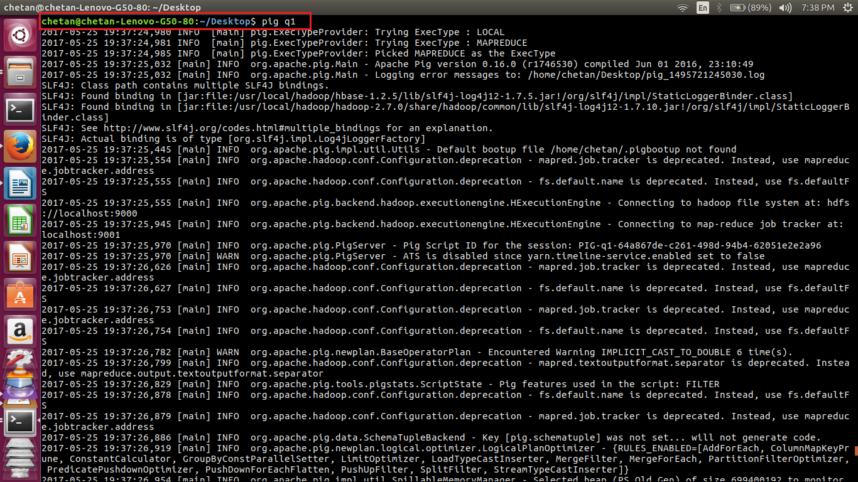

//pig script executed successfully

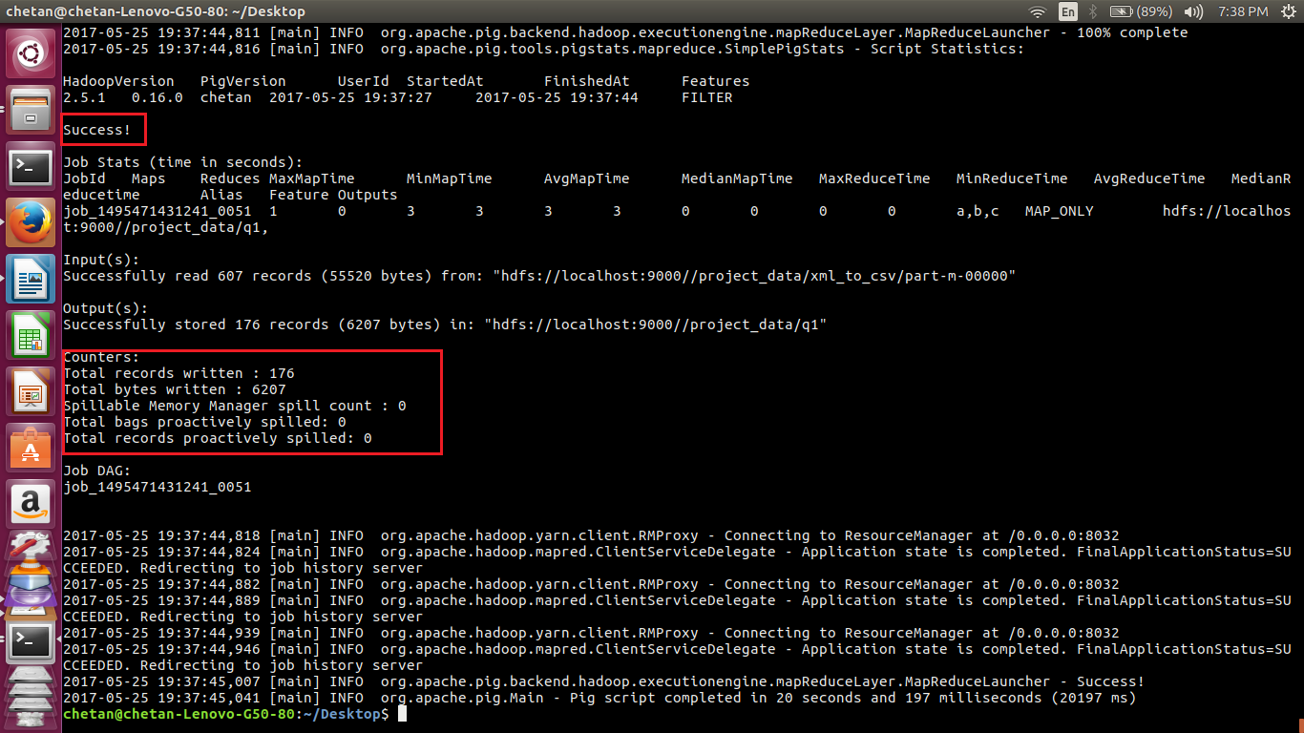

//displaying the contents of the directory and output file.

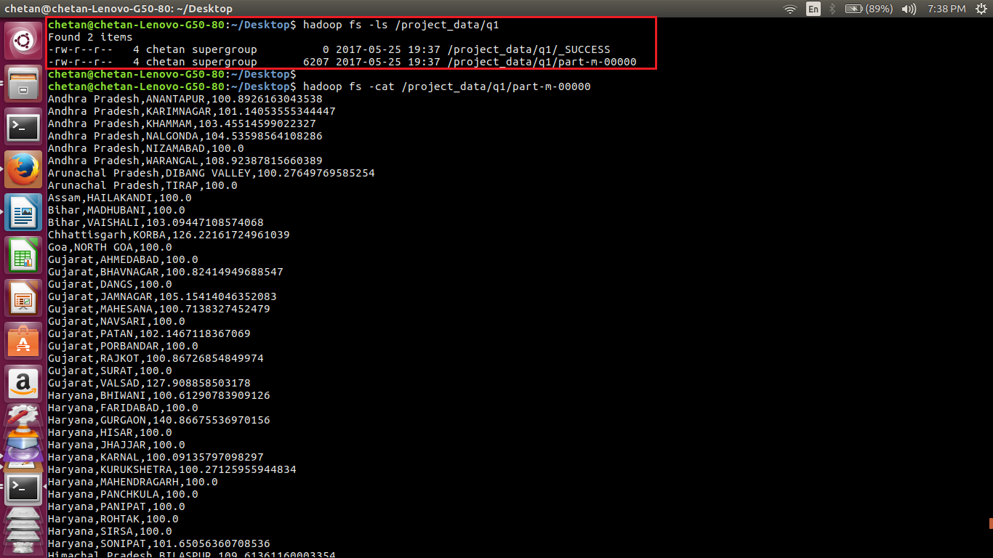

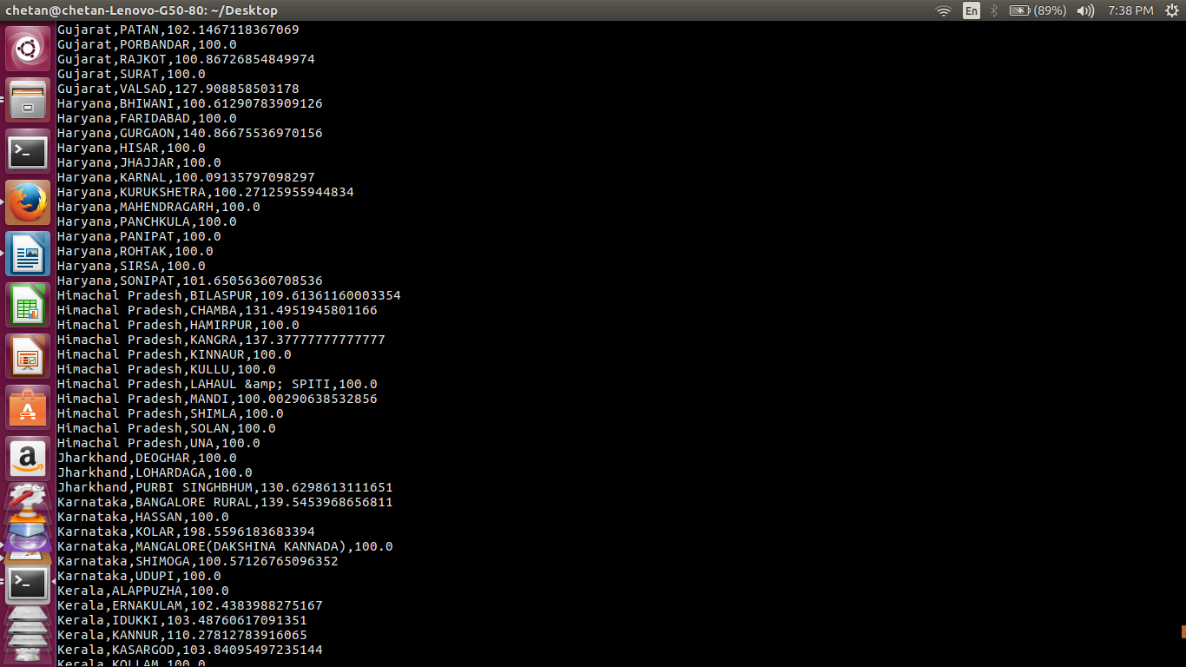

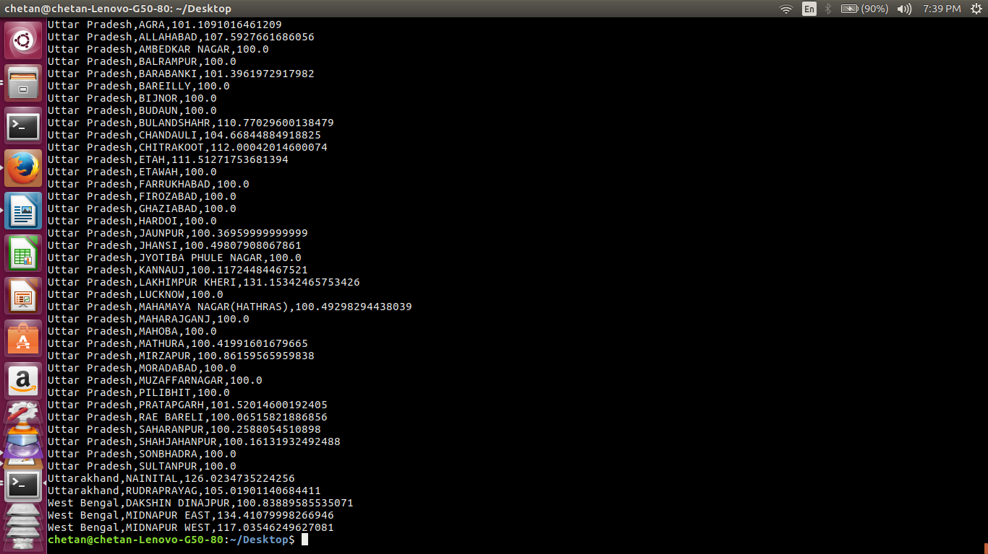

//defining schema in mysql

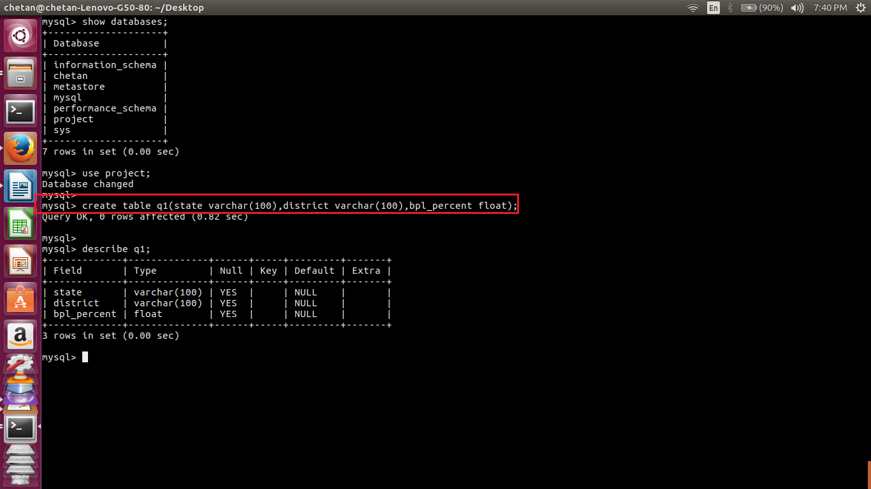

//exporting data to mysql using sqoop

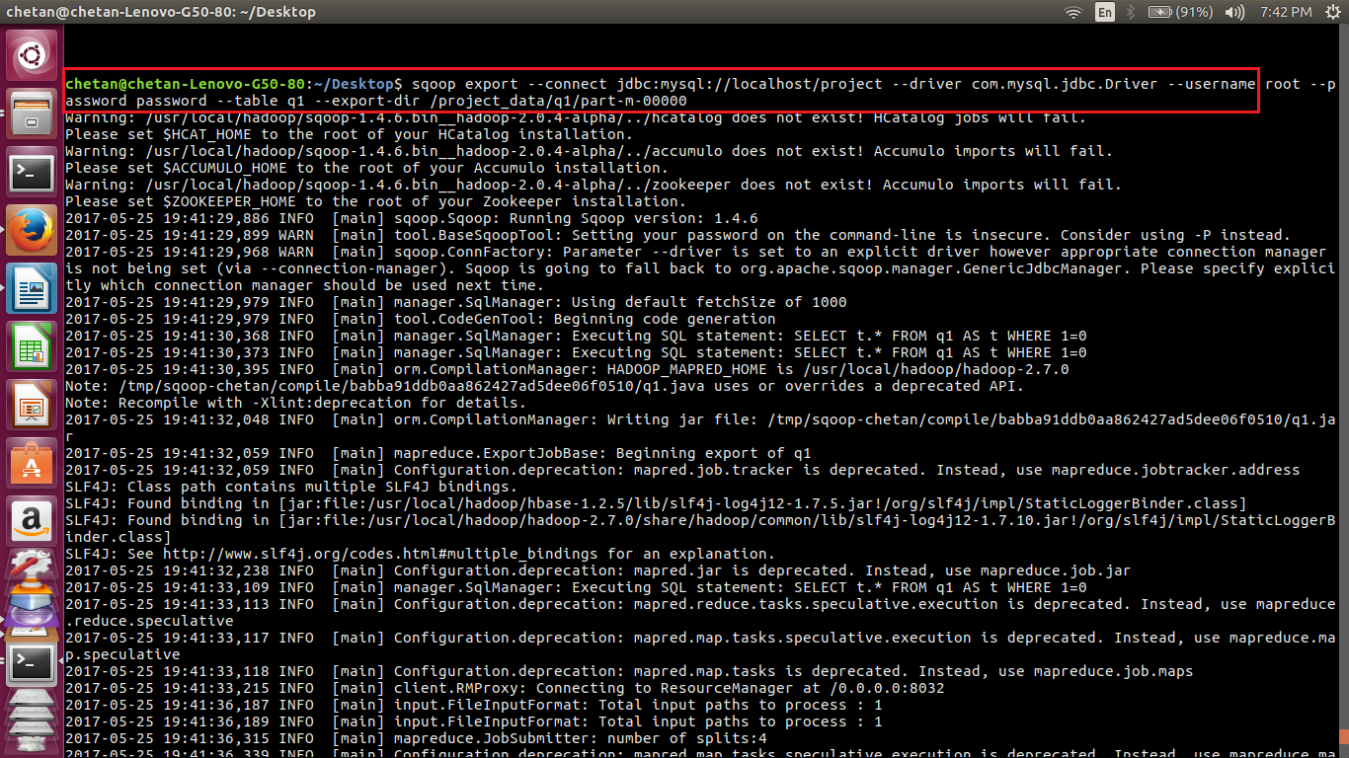

//exported to mysql successfully.

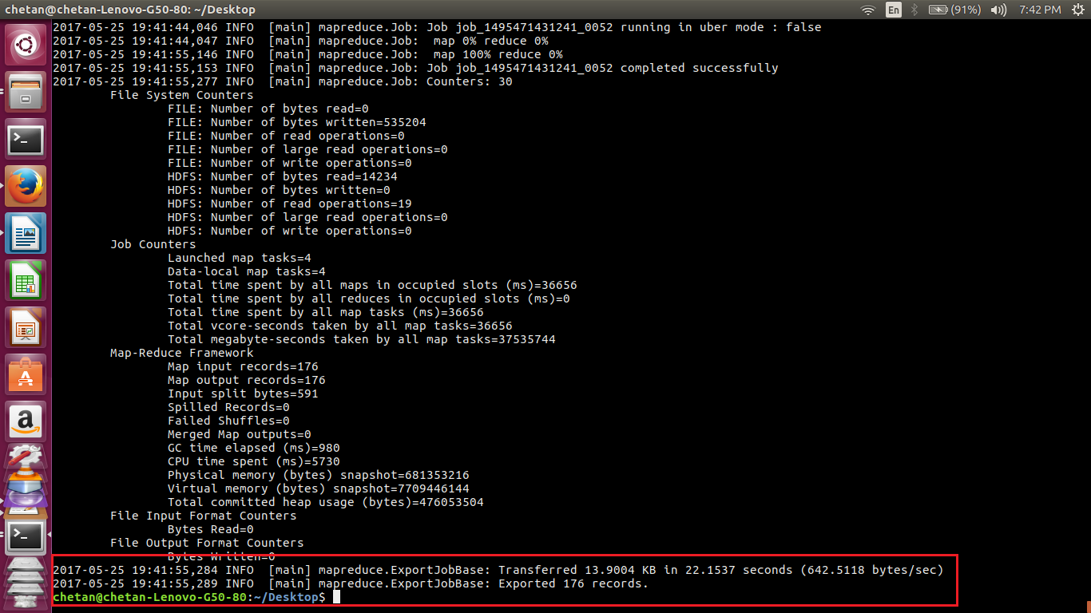

//displaying the records of the table in mysql which were inserted using sqoop

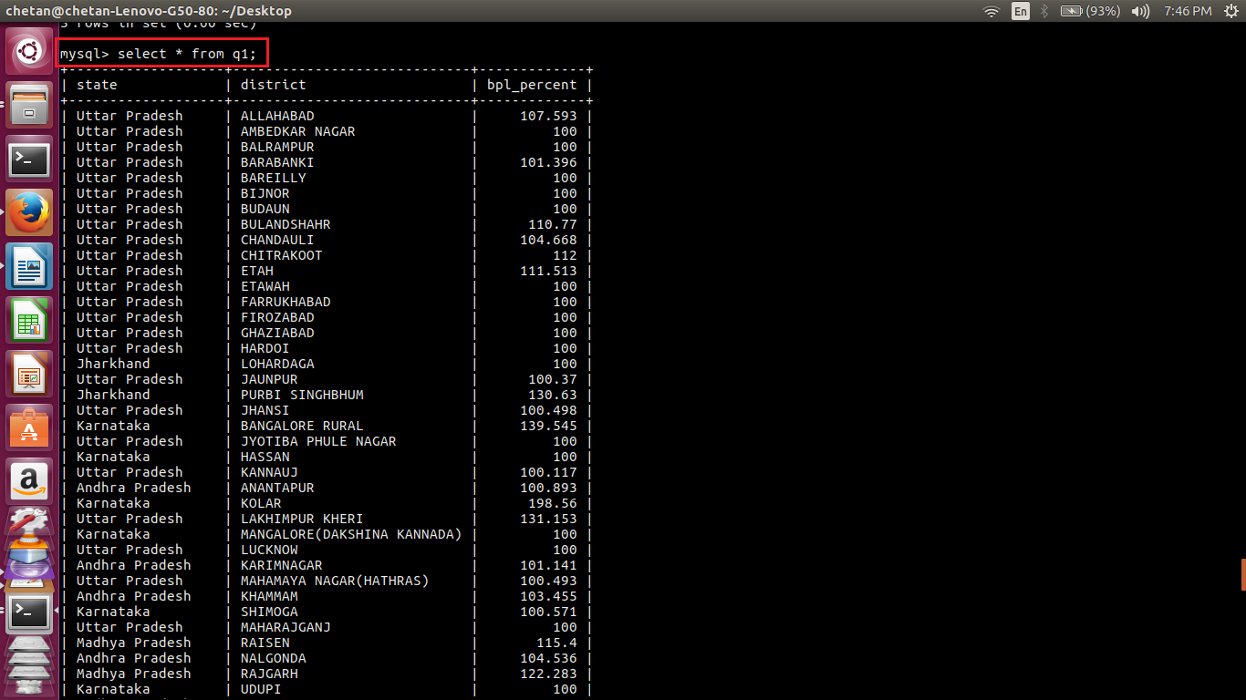

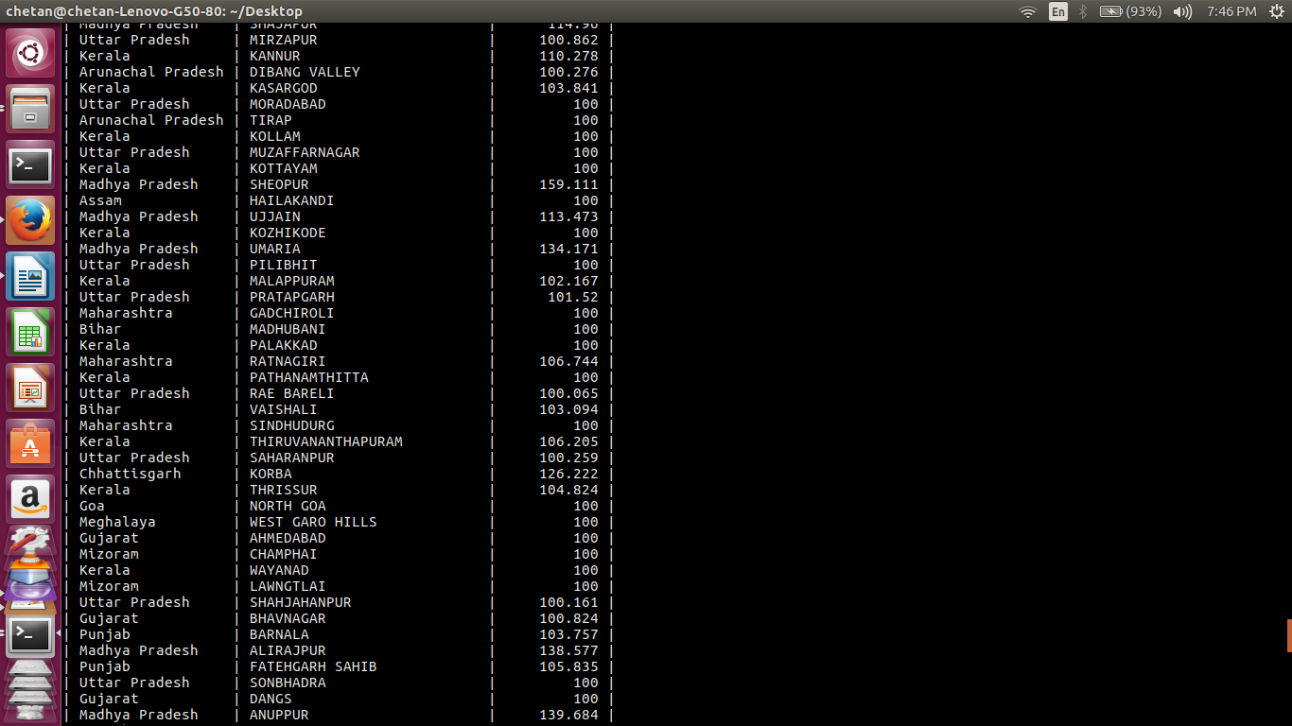

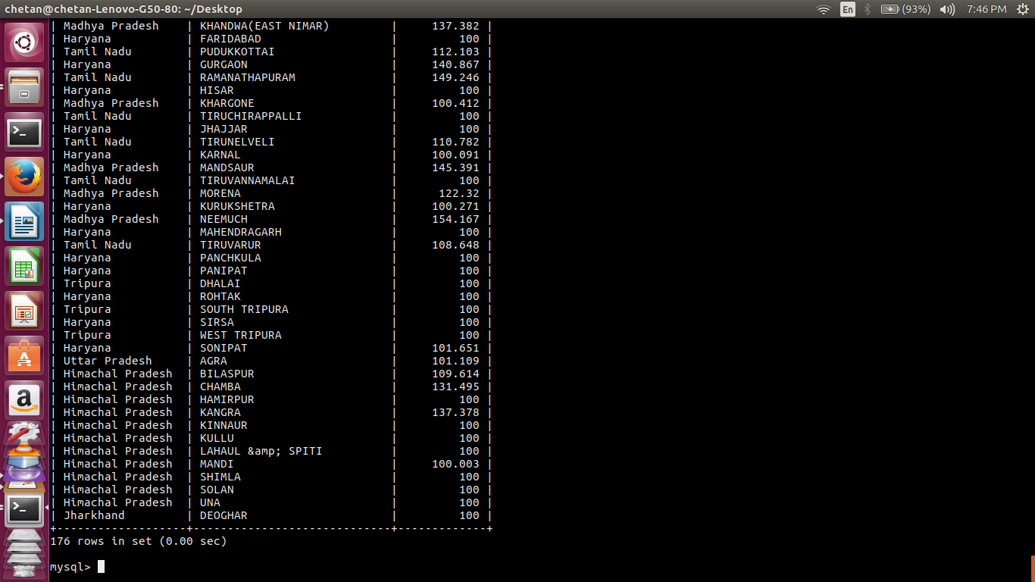

As seen above, a total of 176 records are present in the table.

**STAGE-4:**

In 4th stage, a pig script is written for the following:

Q2-Write a Pig UDF to filter the districts which have reached 80% of objectives of BPL cards.

Later, the results are exported to mysql using sqoop.

//udf code in java

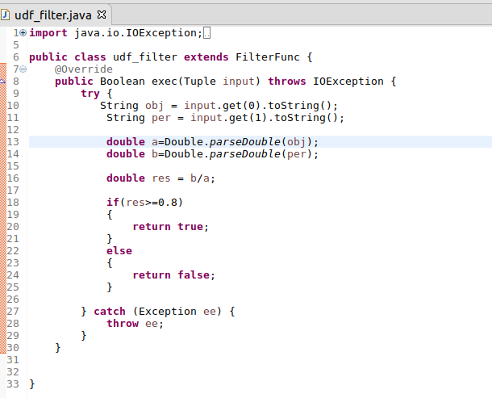

1. The class udf_filter extends the inbuilt class FilterFunc.

2. The function exec is overridden with a return type Boolean.

3. This function calculates the percentage and returns true if the percentage is greater than equal to 80 otherwise, it returns false.

4. The udf_filter class is exported as a jar file.

//copying the jar file to HDFS

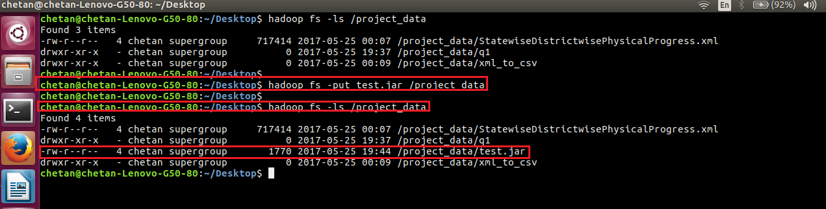

//pig script to execute udf

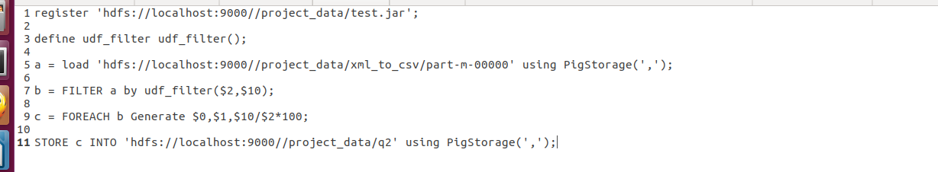

1. Register the jar file and define a function.

2. Load the dataset.

3. Execute the udf.

4. Generate the required the columns and store the result.

//executing the pig script

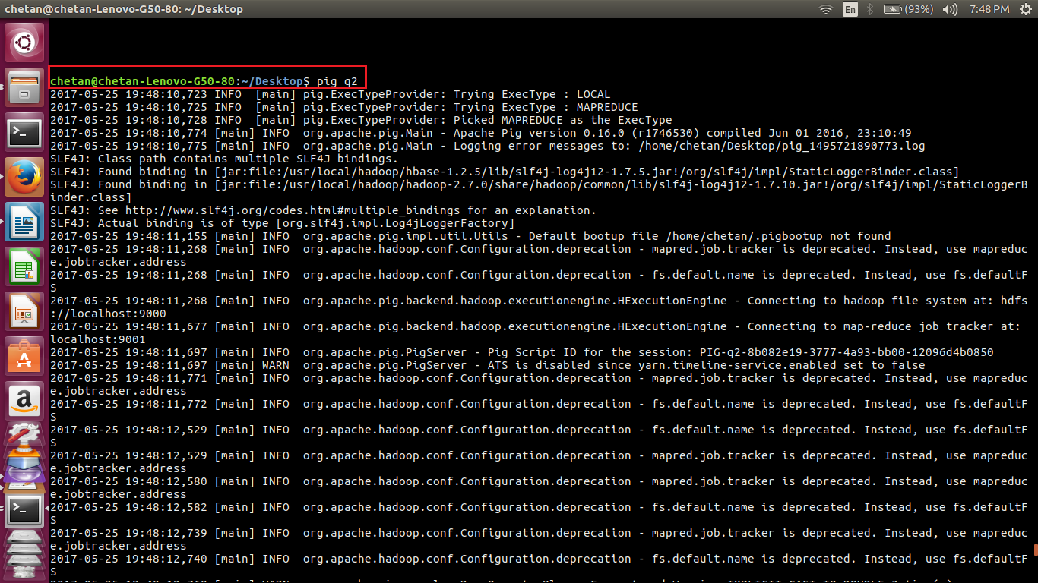

//pig script executed successfully

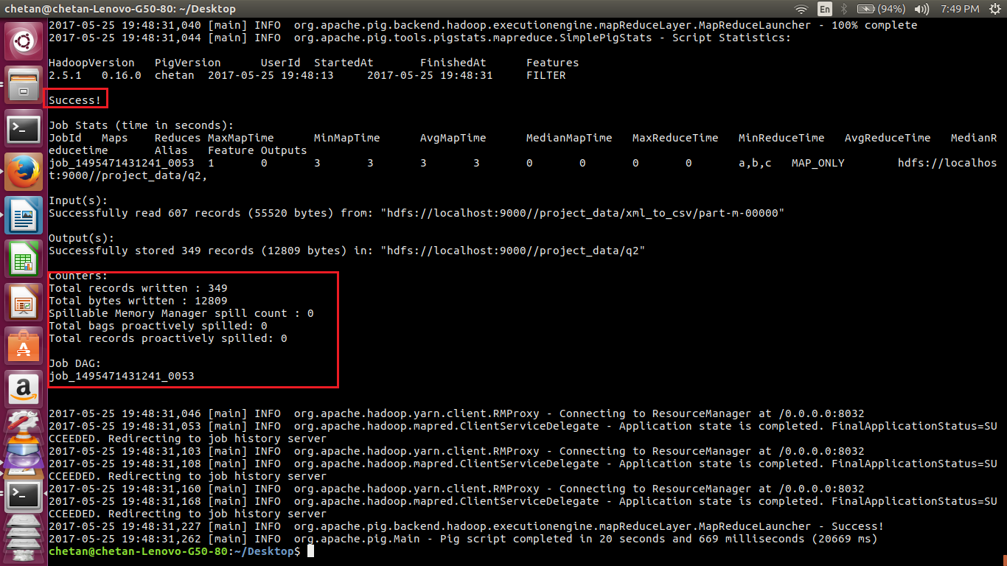

//displaying the contents of the output directory and file.

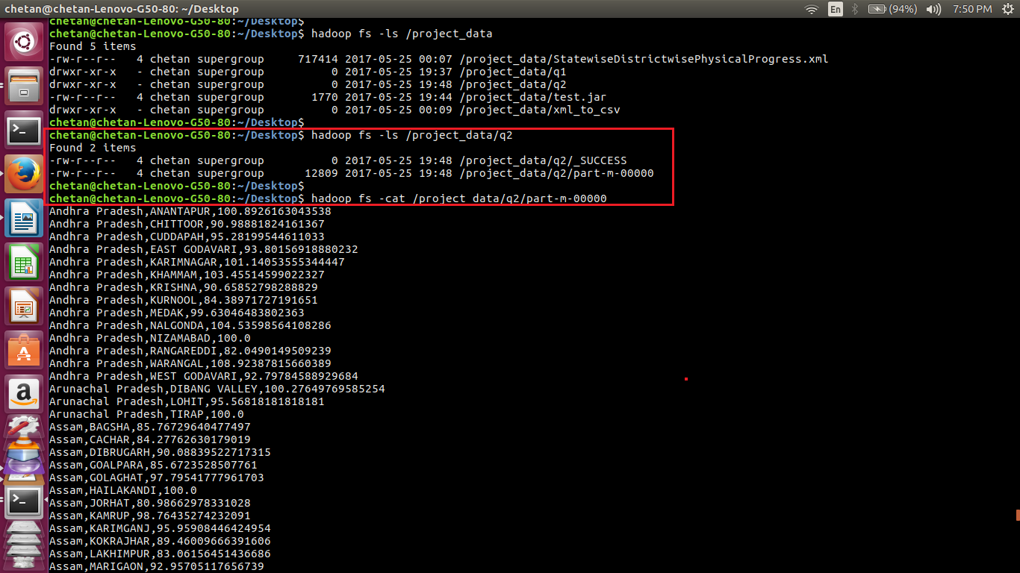

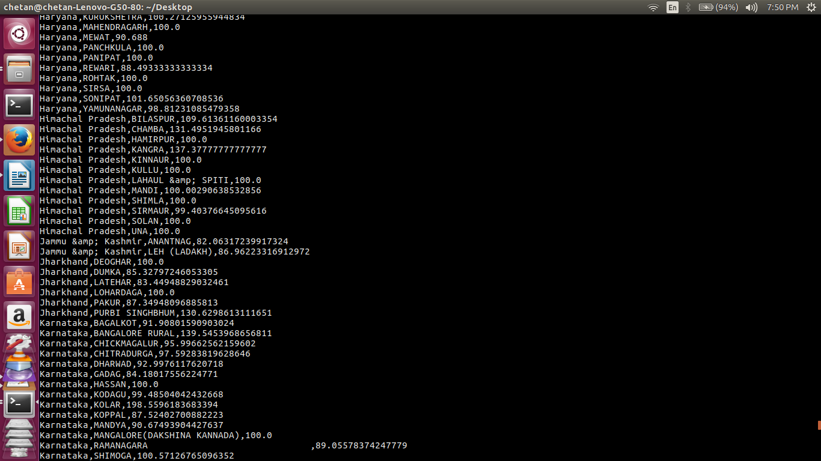

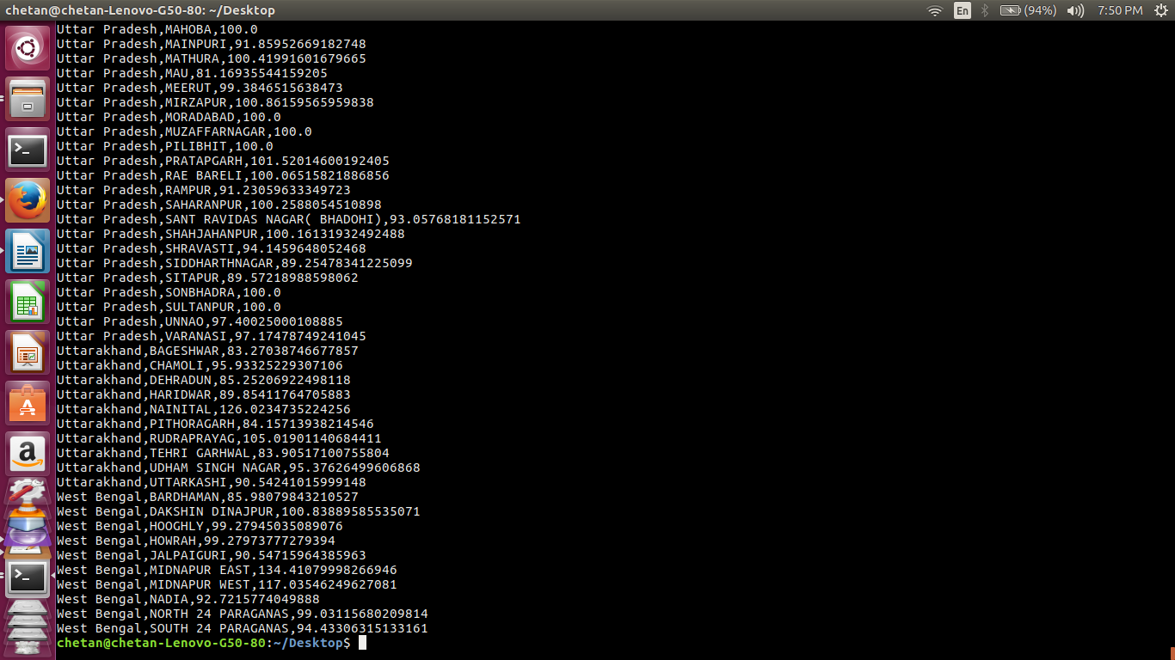

//defining schema in mysql

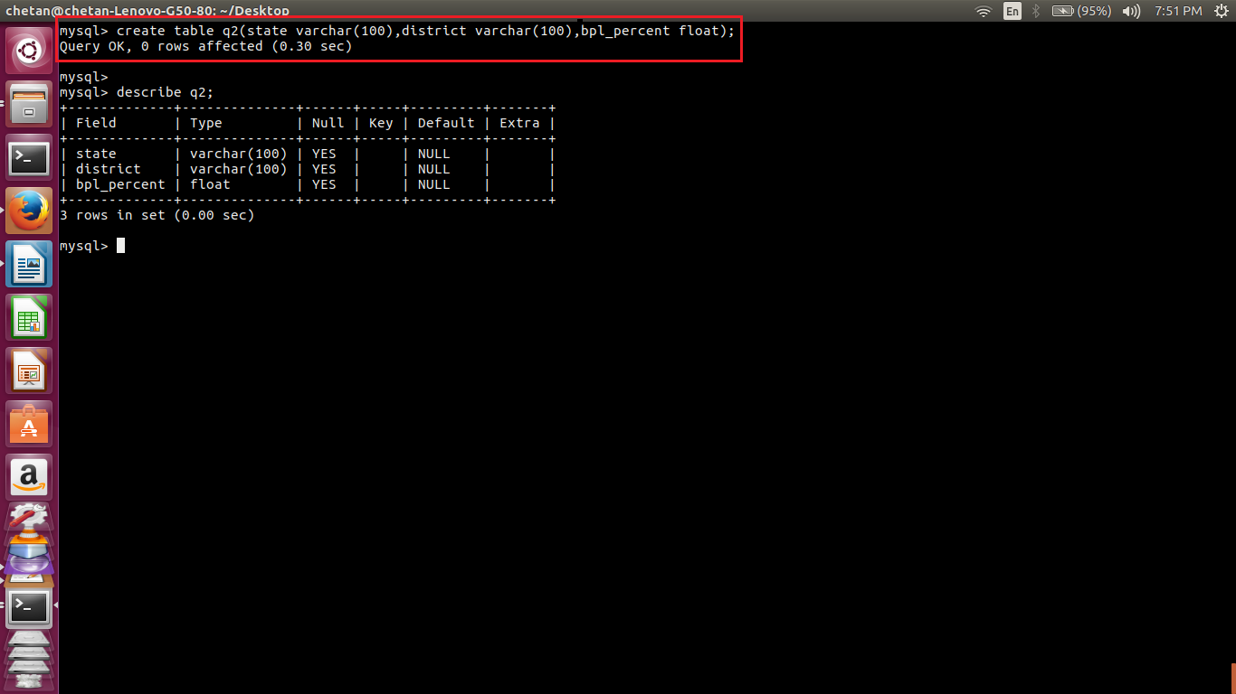

//exporting results to mysql using sqoop

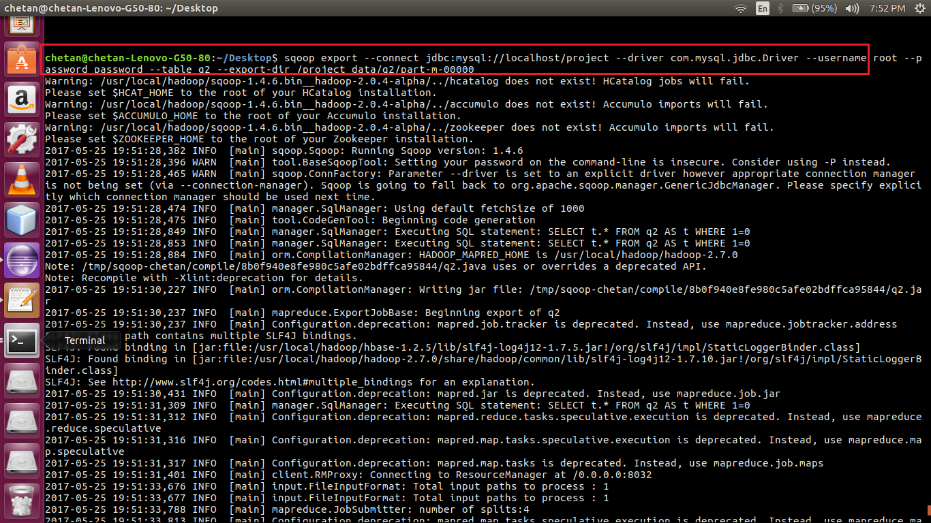

//export complete

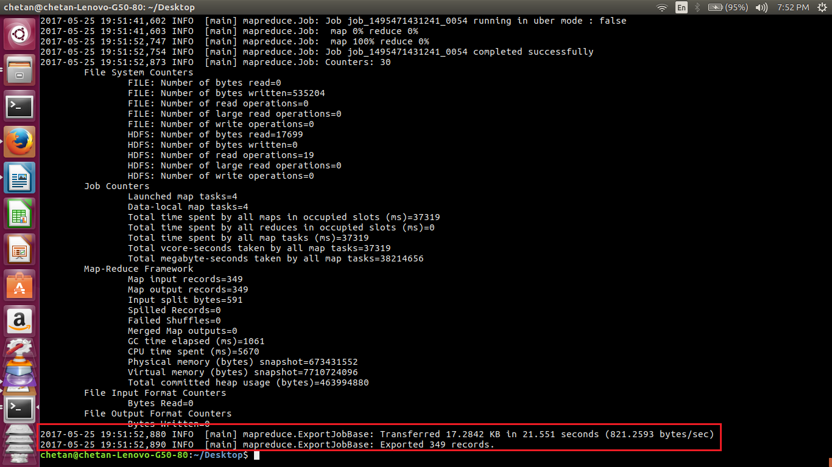

//displaying the records in mysql table

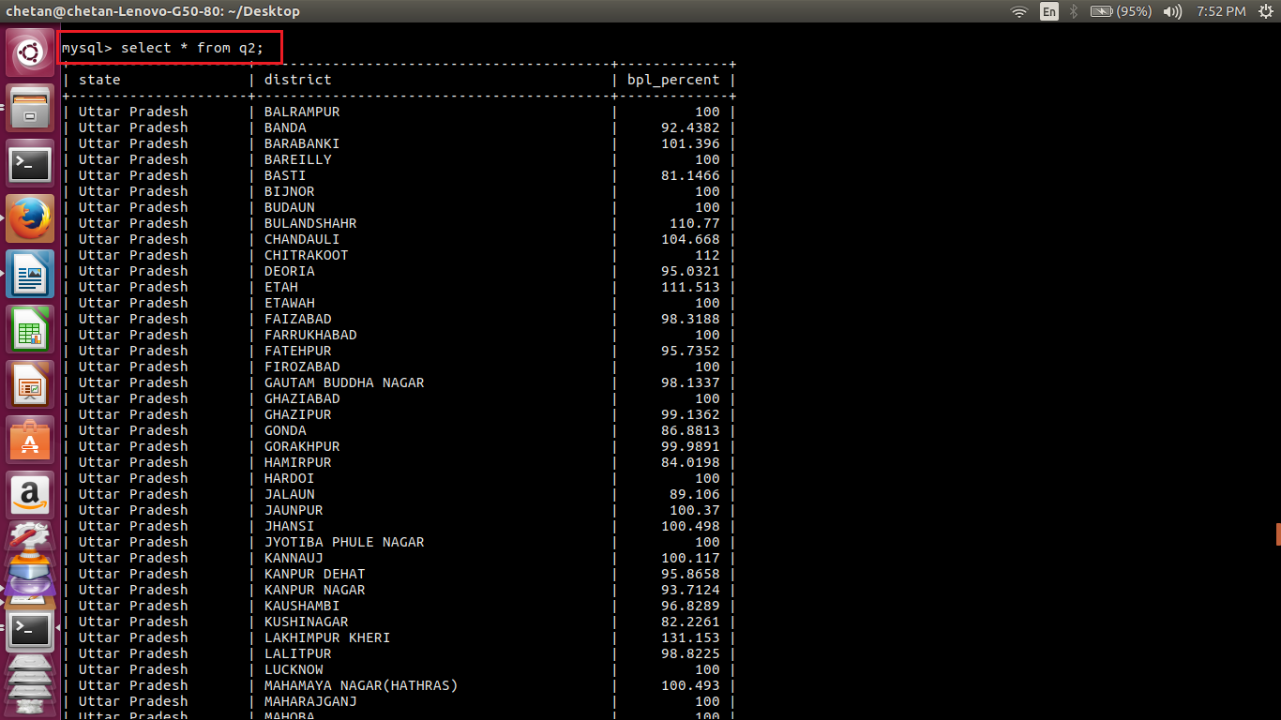

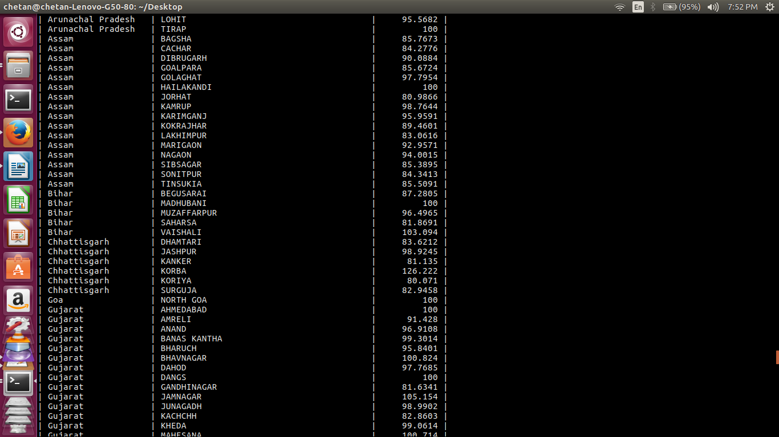

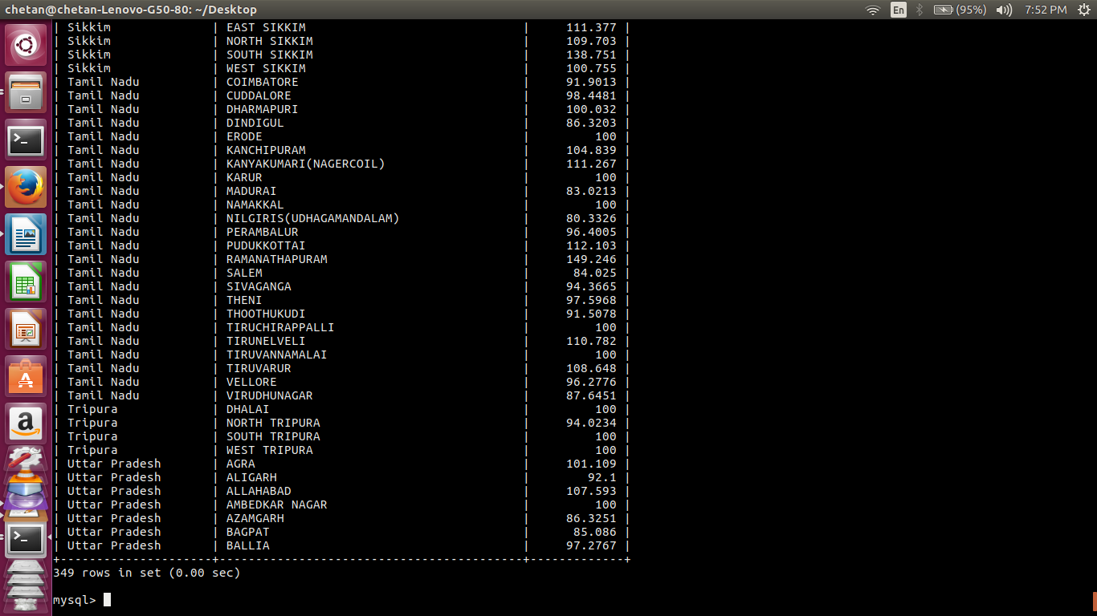

As seen above, the table contains 349 records.

**STAGE-5:**

In the earlier stages, all the components of the project like flume, pig, sqoop are executed separately. In this stage, the process of execution of all commands is automated using a shell script.

Since flume agent keeps on running continuously, another shell script is used to kill the process.

Both the shell scripts ie. Project.sh and kill.sh are executed at the same time.

Kill.sh has a sleep time of 40 seconds, until then the flume job is complete.

Once the 40 second timeout expires, kill.sh terminates flume process and project.sh resumes by executing the subsequent commands.

The mysql commands are not executed in the shell script. A different terminal window is used.

//project.sh (main shell script)

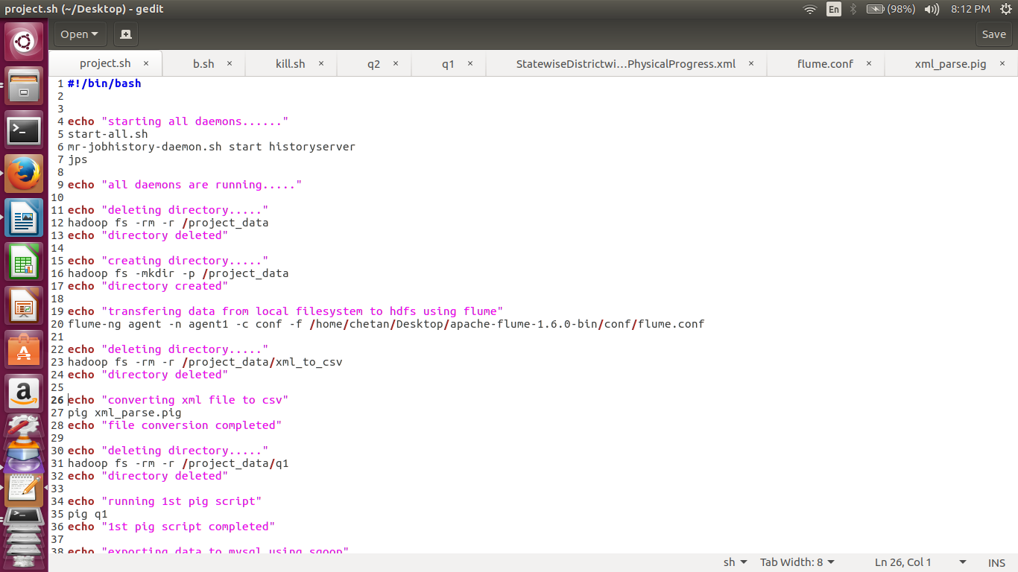

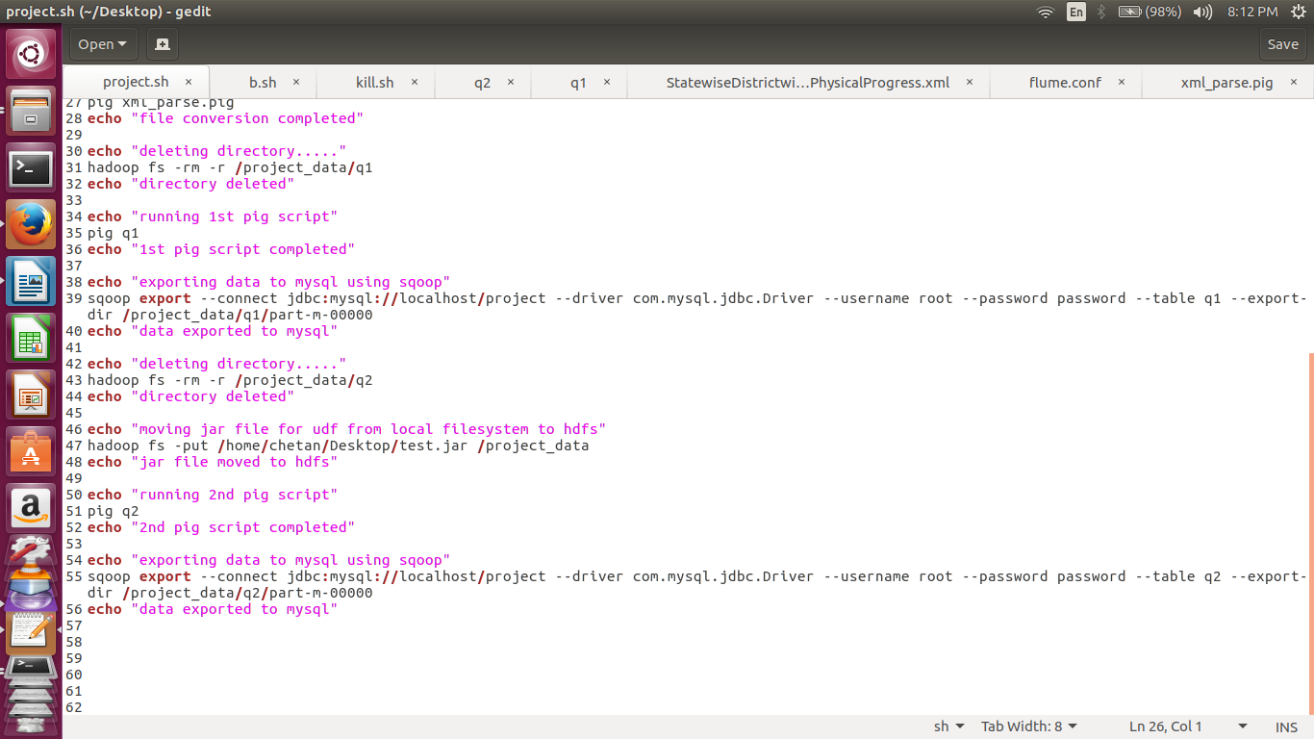

//kill.sh (used to kill flume job)

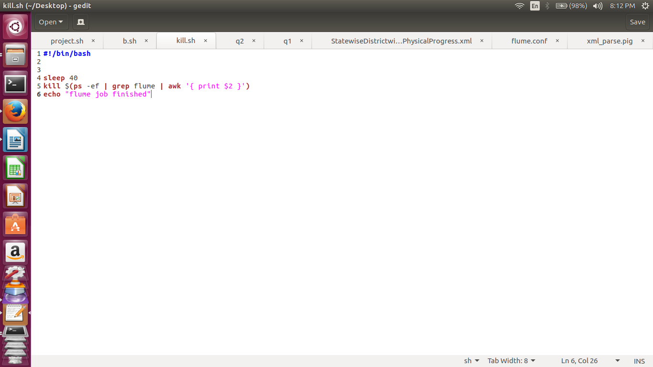

//shell script execution starts

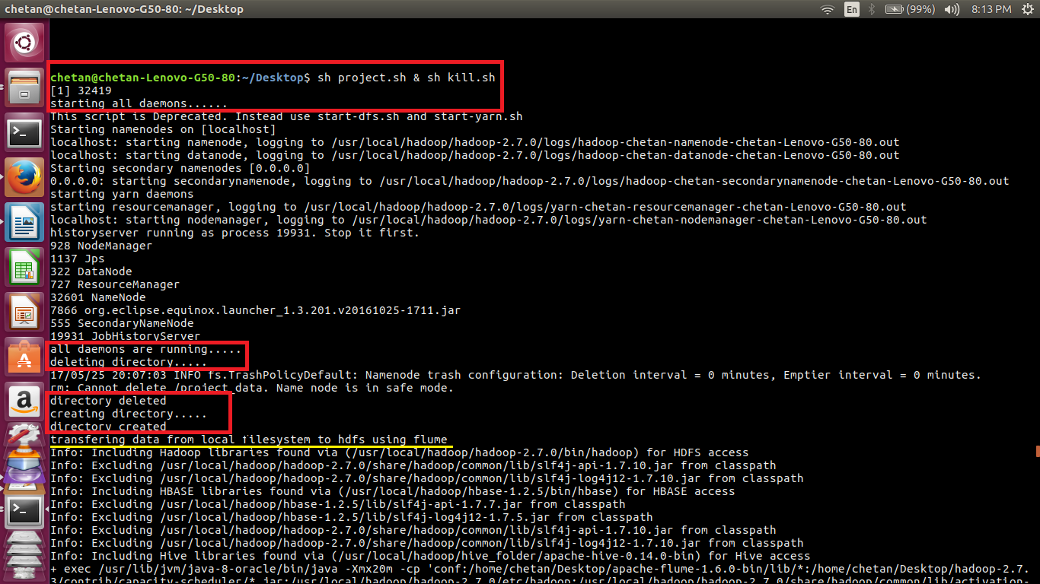

//flume is running

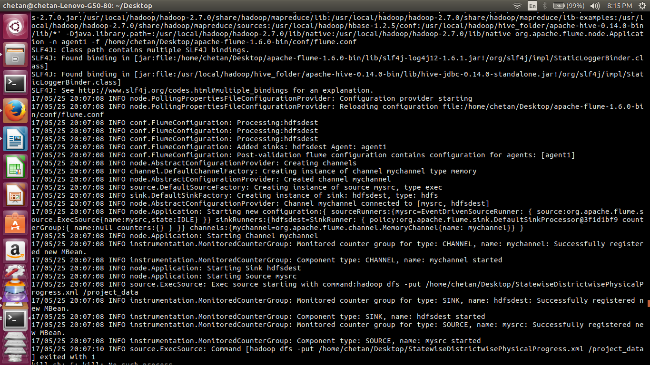

//flume job complete

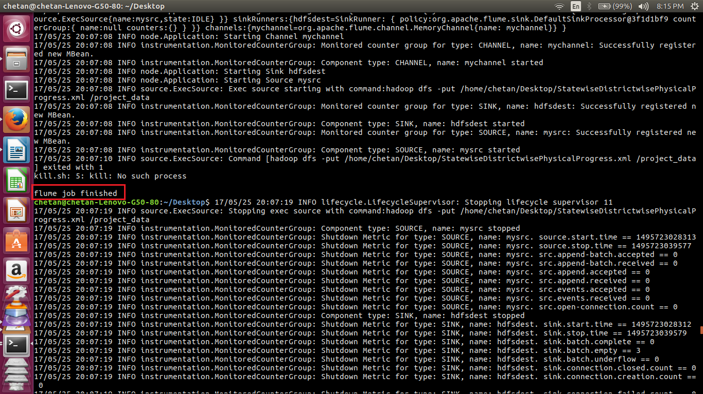

//converting xml to csv

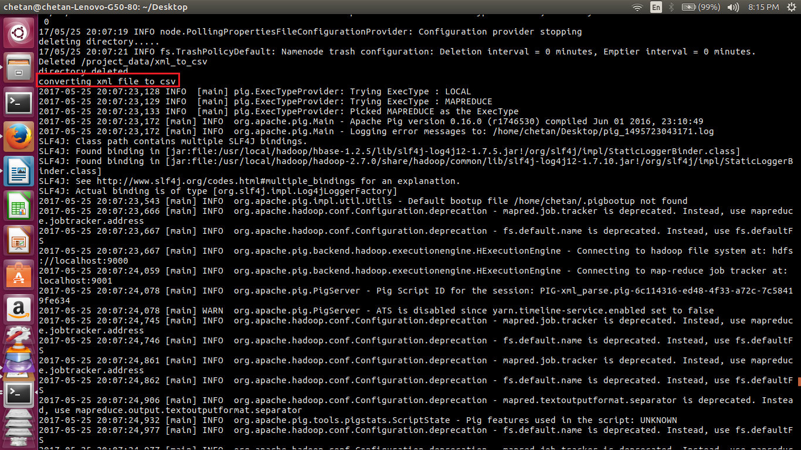

//file conversion complete

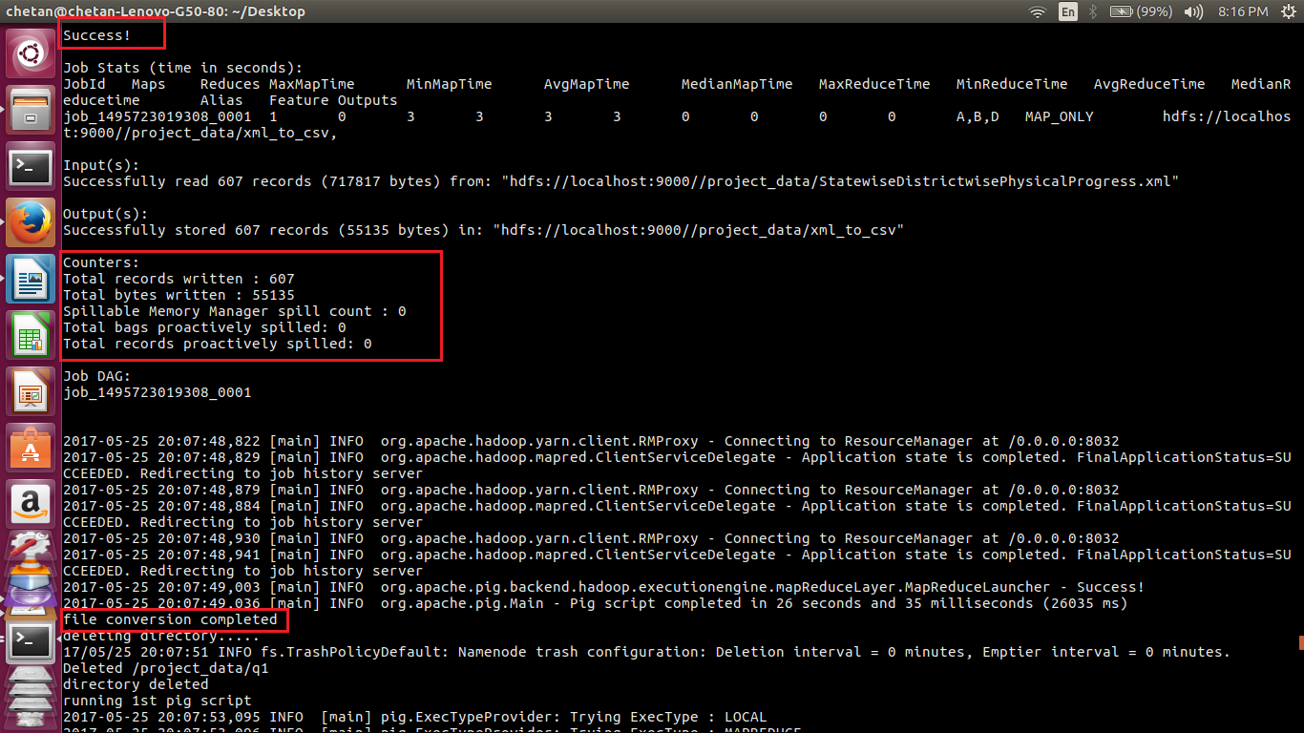

//running 1st pig script

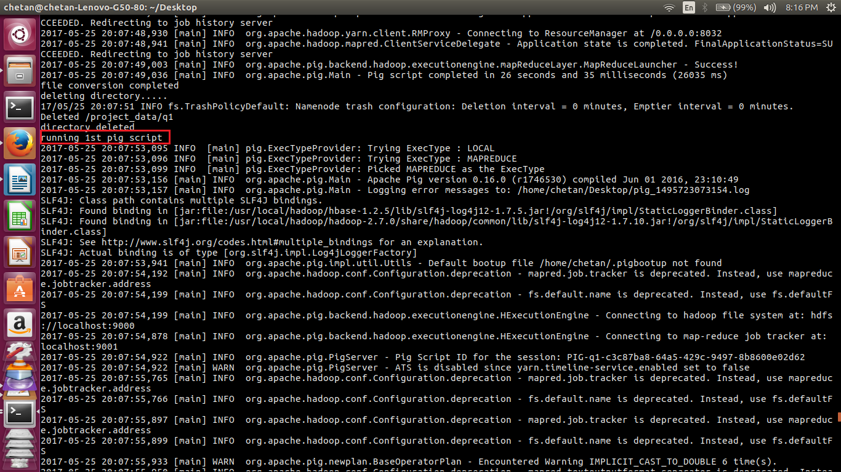

//pig script executed successfully

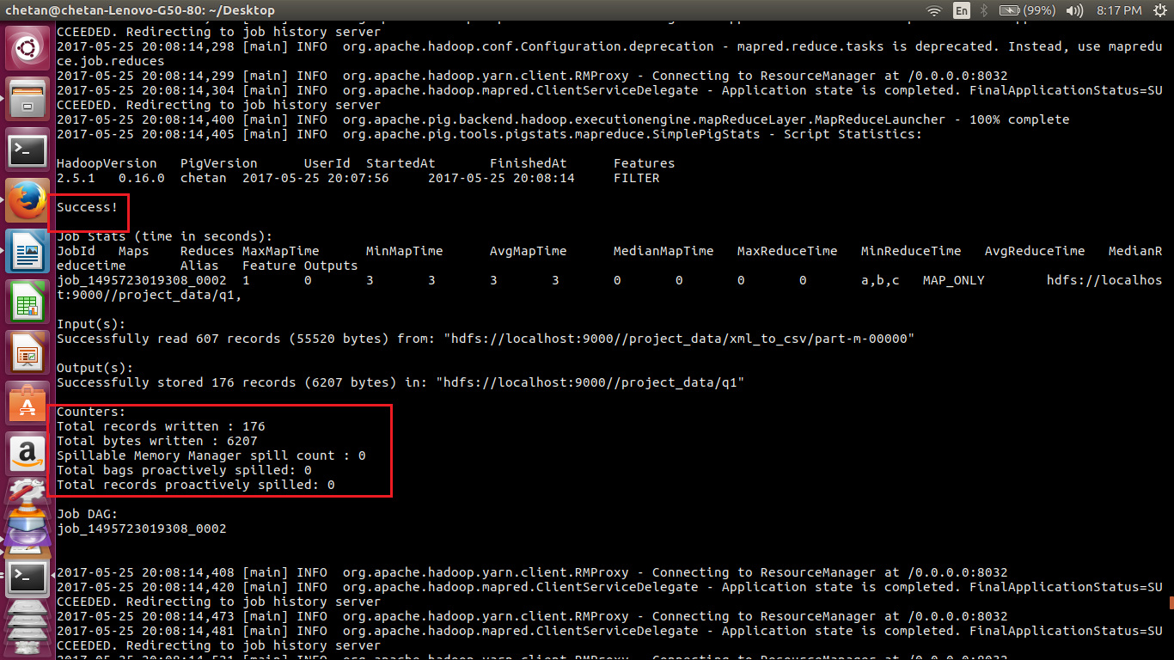

//exporting data to mysql using sqoop

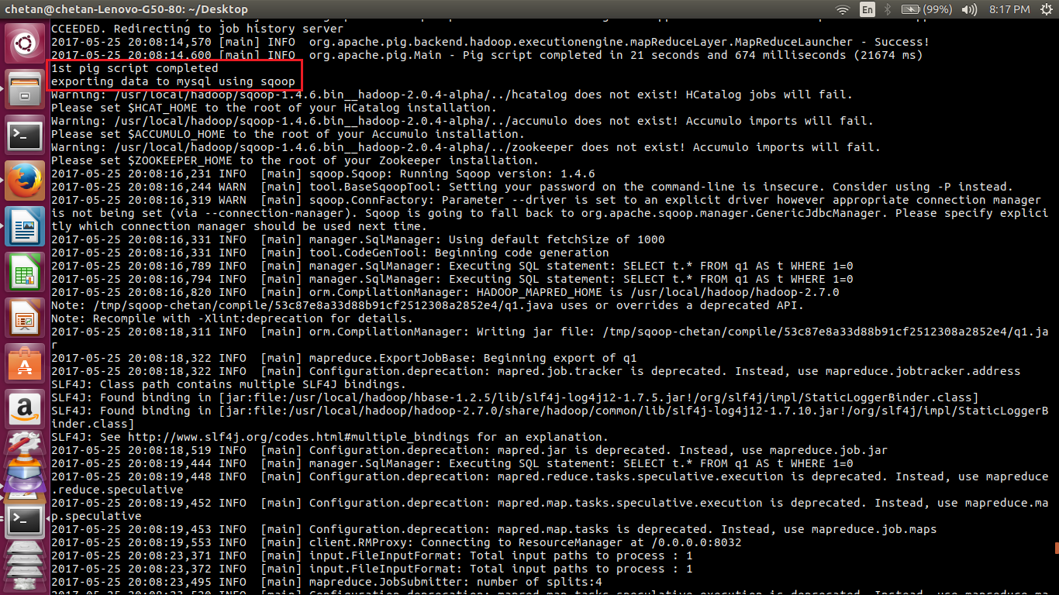

//export complete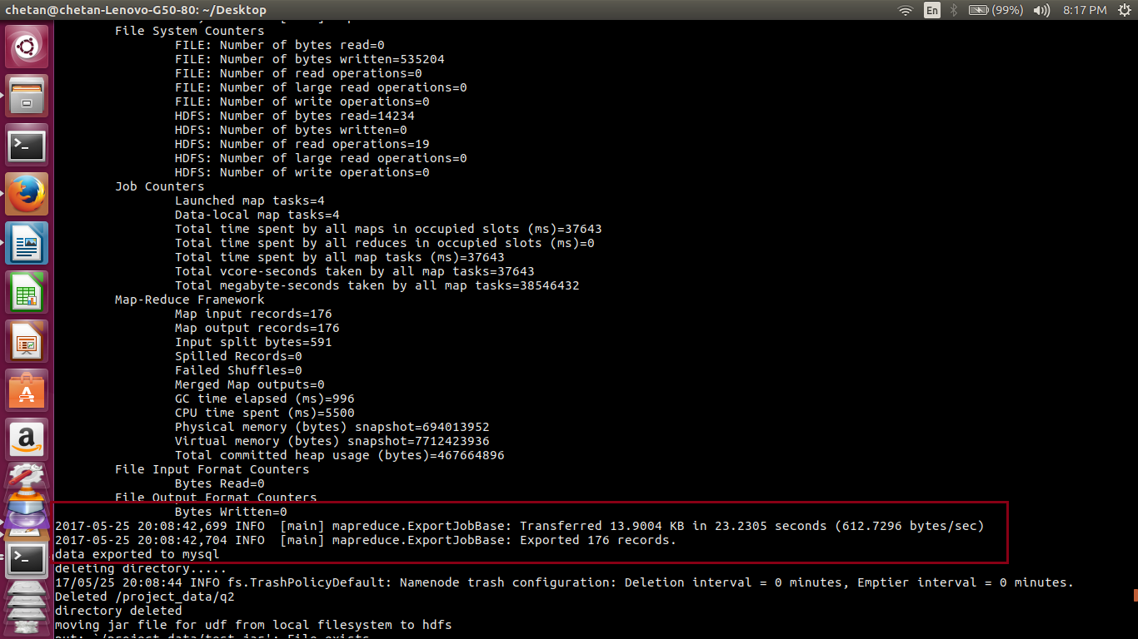

//running 2nd pig script

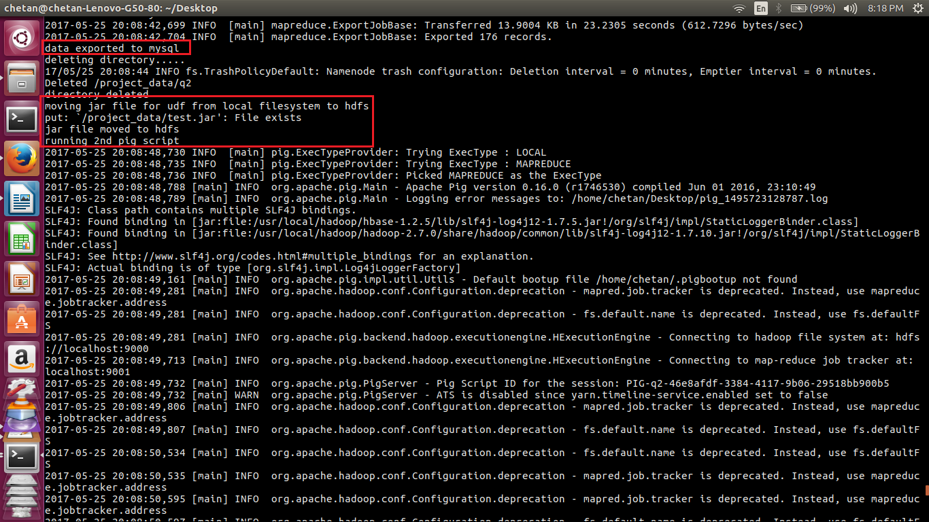

//pig script executed successfully

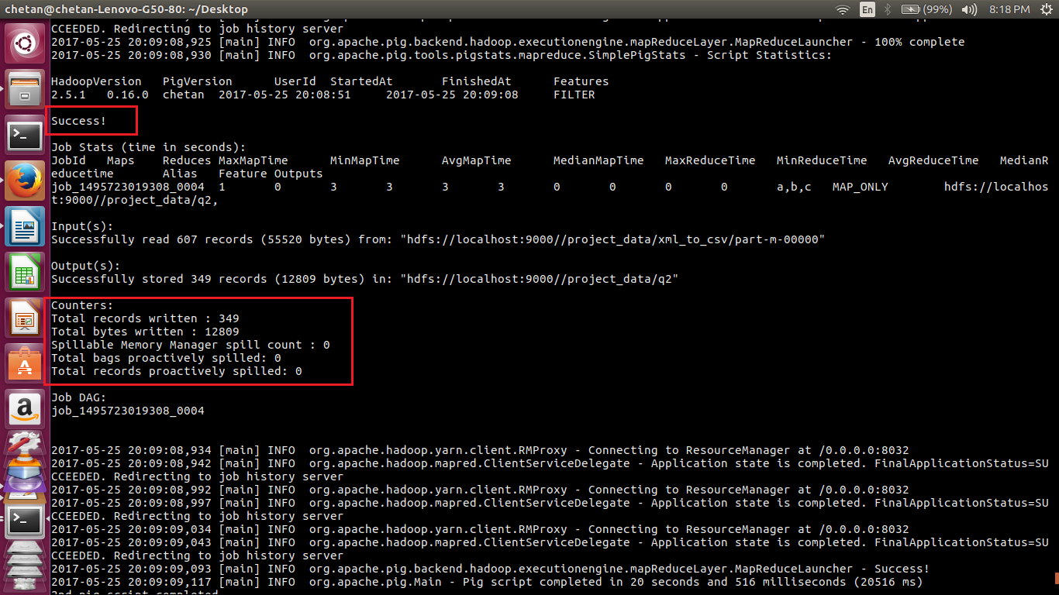

//exporting data to mysql using sqoop

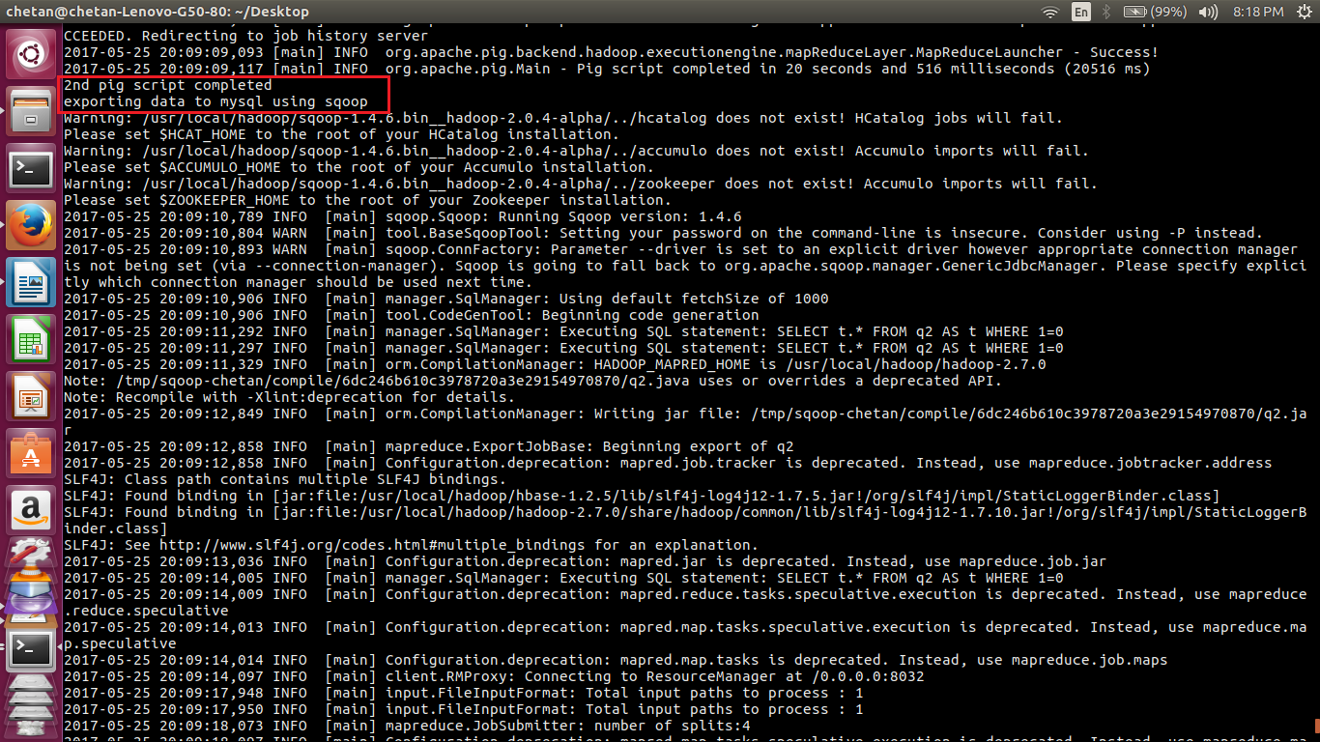

//export complete

//shell script terminated

